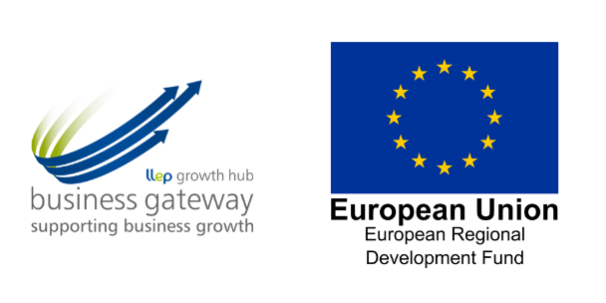

Speaker and Panellist Profiles

Ian Lockwood  Ian Lockwood is an Online Marketing and Web Design Specialist, specialising in SEO, PPC, Google Analytics and conversion rate optimisation.  08.45 What’s New in Search 2023  Ian will give the latest insight into the ever-evolving world of search engines, from developments in the world of machine learning and AI to new Google and Microsoft Ads features. Ian will explain the practical implications of Google and Bing updates over the past few months, showing you how to adapt your website and content to stay current, whilst taking advantage of the new opportunities on offer. | 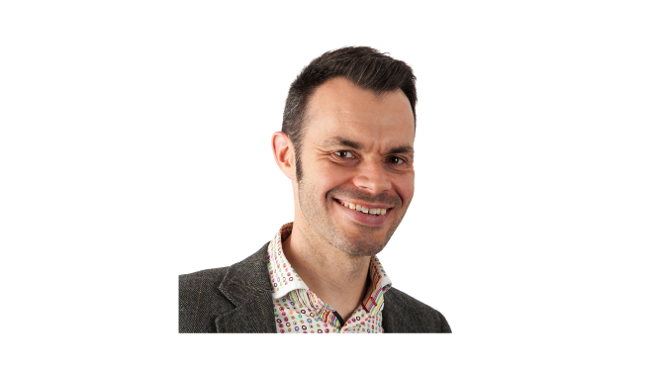
Martin Broadhurst  Martin Broadhurst is a digital strategist (majoring in Email Marketing, CRM and Automation) as well as a Chartered Institute of Marketing tutor and experienced digital agency leader.  09.45 Marketing in the Age of AI: Preparing for an  AI-Powered Future  Martin will explore how artificial intelligence is transforming the world of marketing, from personalised customer engagement to predictive analytics and beyond. Learn about the latest AI technologies and strategies for staying ahead of the curve in an increasingly AI-powered industry. | 
Paul Ince  Paul Ince is a digital marketing strategist and owner of 'Like Mind Media' in Loughborough. He is a firm believer that the people working within the business are best placed to talk about it, supporting them to increase their visibility online and grow their business through digital technology.  11.15 Everyone’s a content creator. Yes, even you…  Whatever your business, your customers are consuming more content than ever before they get in touch. Website content, blogs, articles on LinkedIn, Tik Tok, YouTube video, email, even posters and business cards. How do you keep up with which marketing channels to use and which content types to focus on? And who’s going to create it all?  Paul will consider the routes your customers may take, and which content types are working right now. We’ll also show how using your entire team will help you increase the volume of content you can produce within your business and when it makes sense to get help. | 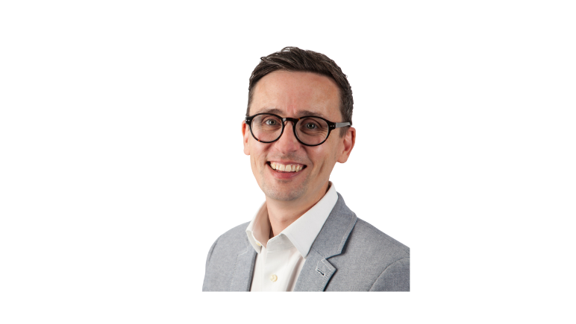
Liam Lally  Liam Lally has carved out a reputation as one of the East Midlands' leading authorities on all things social media/networking. His enthusiasm and dedication to helping businesses get the most out of their investment in online marketing is evident to all. He is also a Google AdWords Certified Partner.  12.15 Why you should resist the march towards automation in  Google Ads  Google has made many changes over the last 18 months regarding their pay-per-click advertising product Google Ads. Liam will consider who REALLY benefits from these changes and how you can ensure you choose which automations might be useful for your business, and which you might want to avoid. | 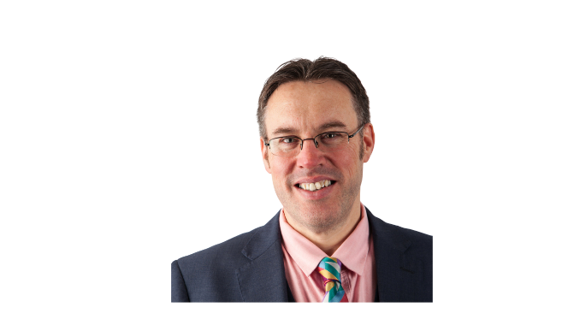
Rob Gregory  Rob Gregory is a Founding Director of Magnifica, a tech agency based in Chesterfield. Rob has significant experience across a broad range of digital applications, from Custom Software to Website Development. His message is that technology must be used to simplify business processes and provide a true return on investment.  14.15 Robots hate you and your website. But why?  AI went mainstream in 2022 with the launch of hundreds of new apps, tools and products - all set to take over the world of marketing and website development. You could be left wondering what’s left for you to do as a business owner and marketeer.  Rob will explore how robots want to take your place (in reality they can’t, well – not just yet). See a robot do amazing things in a few seconds but also discover why you are still better at building a website and marketing your products and services than they are. | 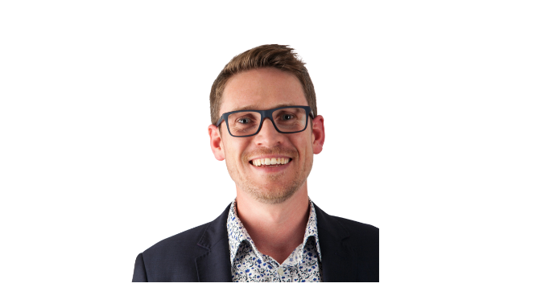
Diane Beresford  Deputy Chief Executive, East Midlands Chamber  15.15 The future of digital support in Leicestershire  Diane will provide an update on digital support for local businesses following the end of the European-funded programmes. | 